Recommending Alpha

Group #16

Data Collection

**Group Members:**

Vedanta Dhobley: vjd41@scarletmail.rutgers.edu

Avani Bhardwaj: ab1572@scarletmail.rutgers.edu

Shazidul Islam: si194@scarletmail.rutgers.edu

Akshat Shah: avs91@scarletmail.rutgers.edu

Kutay Kerimoglu: kk851@scarletmail.rutgers.edu

Alan Patel: akp122@scarletmail.rutgers.edu

Anthony Matos: amm720@scarletmail.rutgers.edu

Joel Cruz: jc2125@scarletmail.rutgers.edu

Database Collection Screenshots (For a little idea of our database)

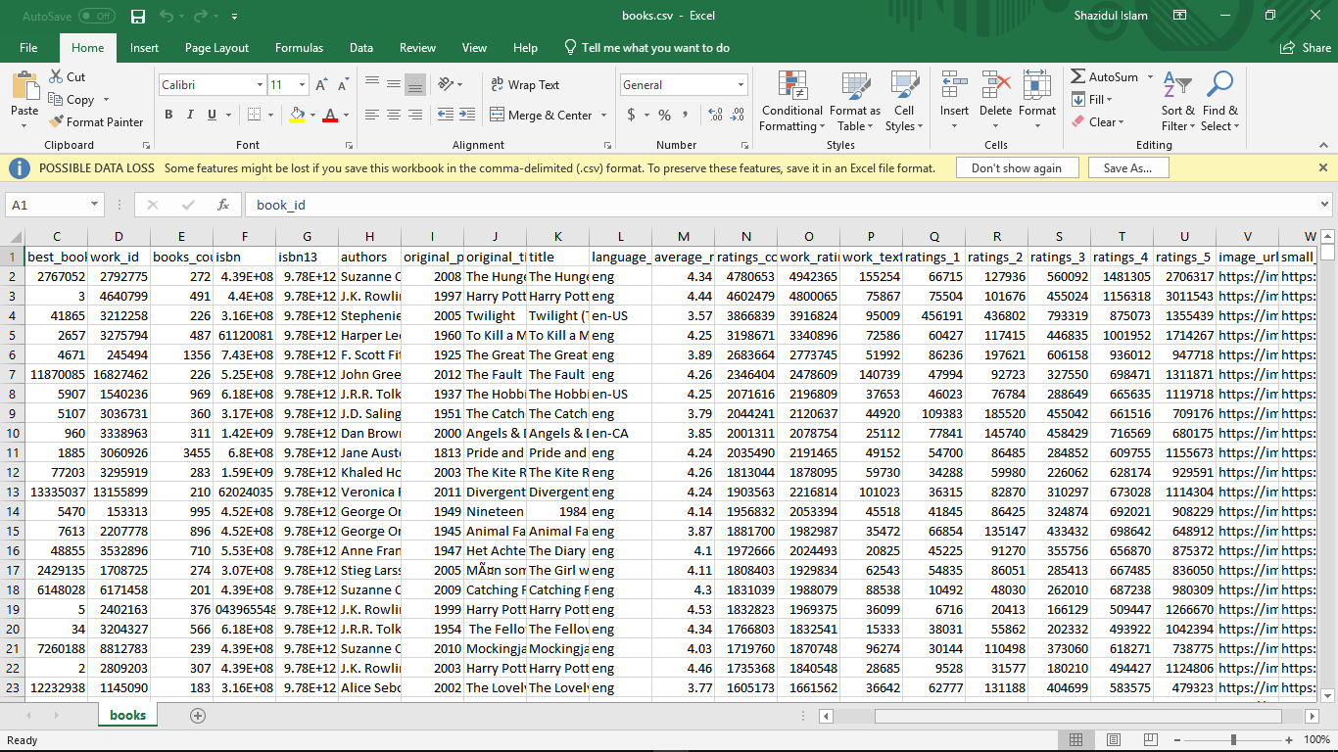

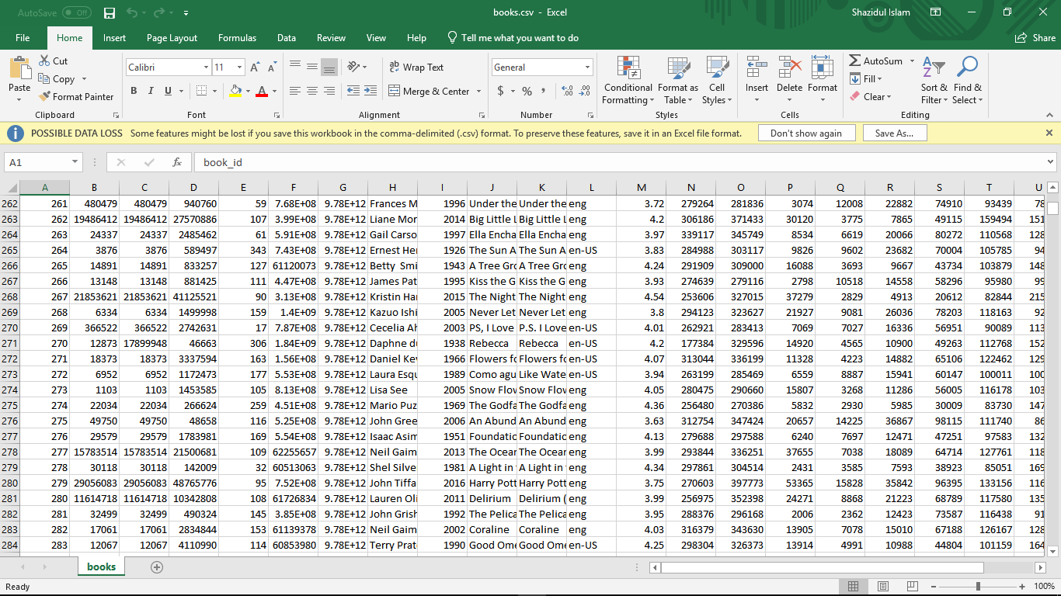

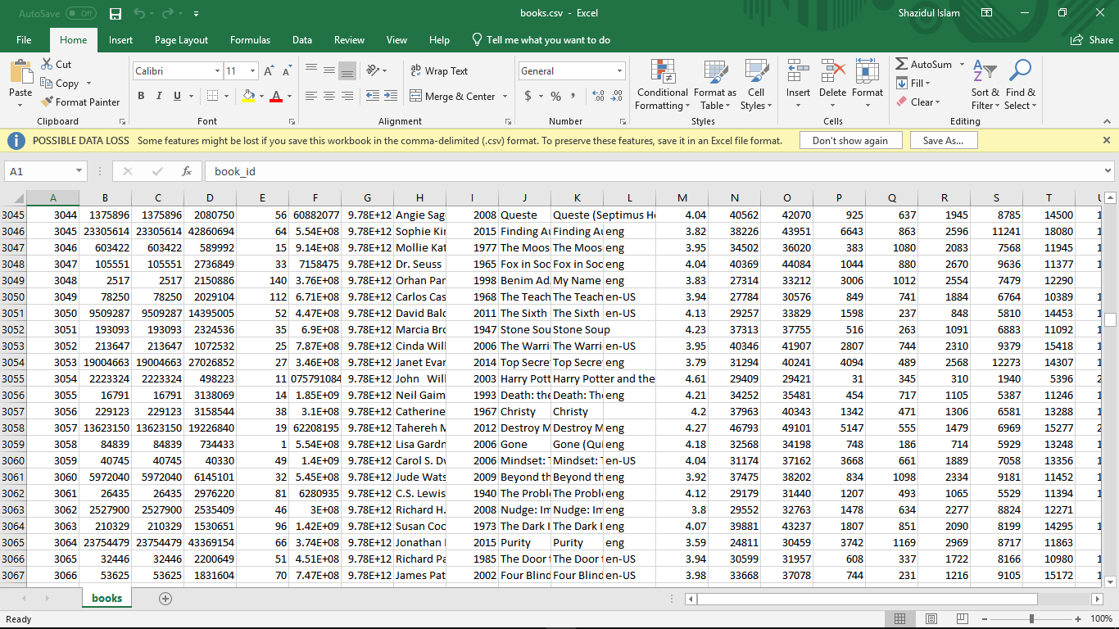

Tags

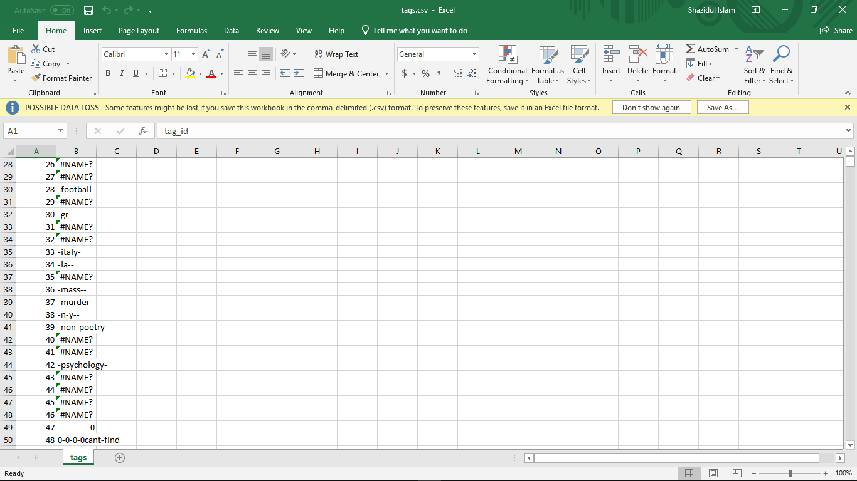

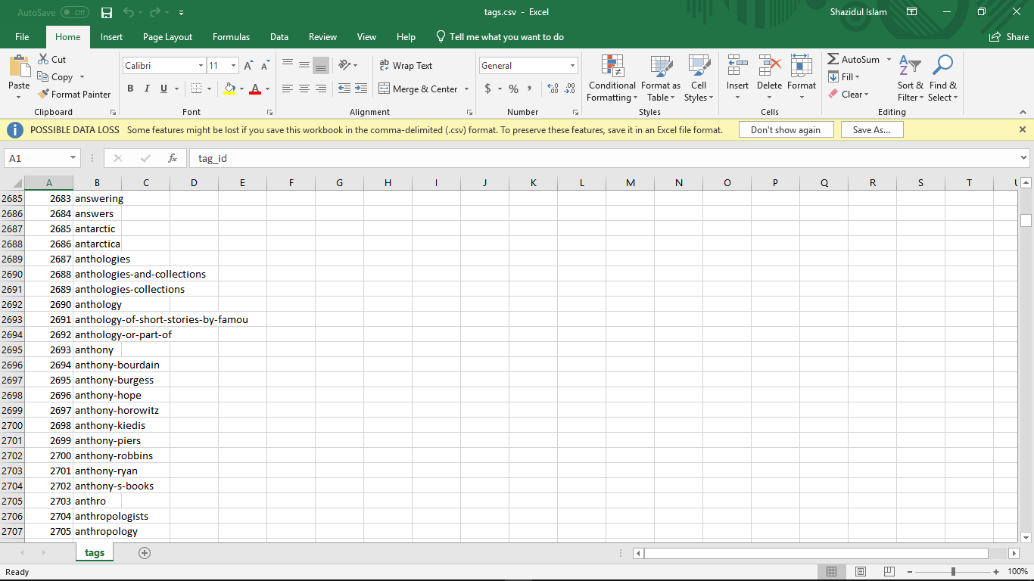

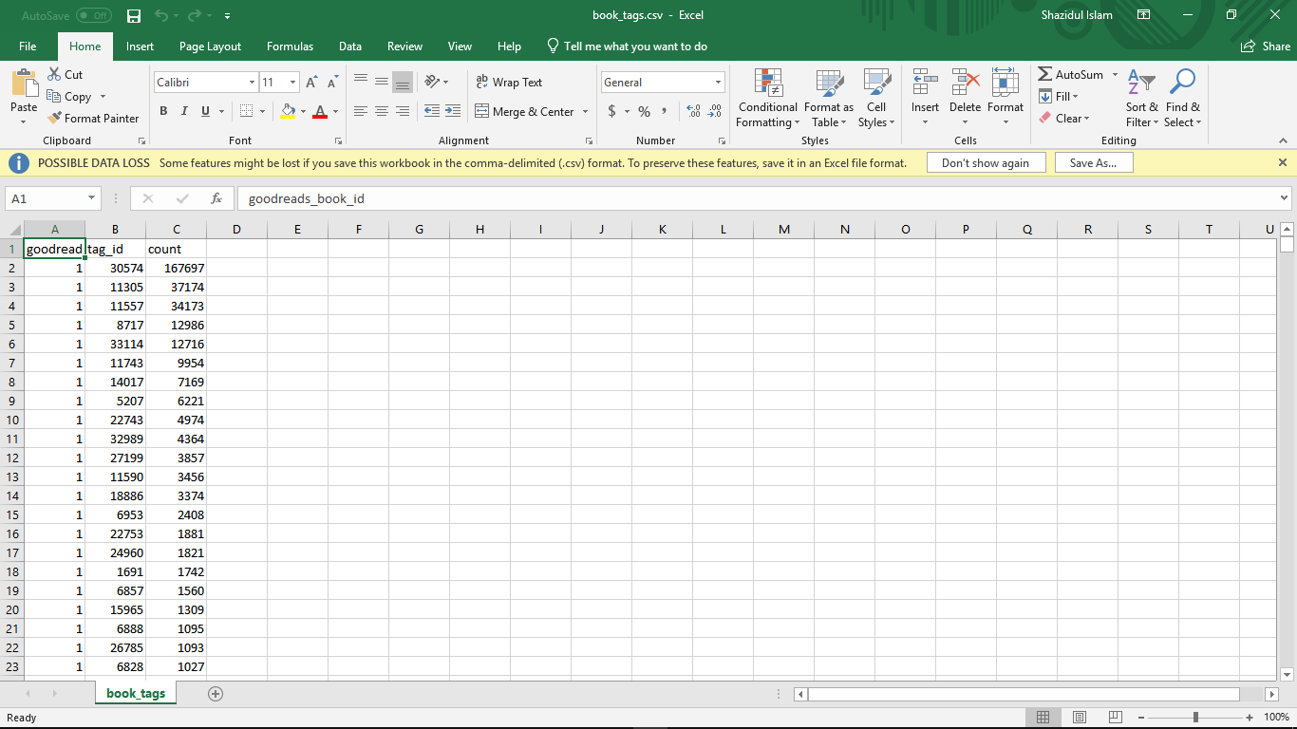

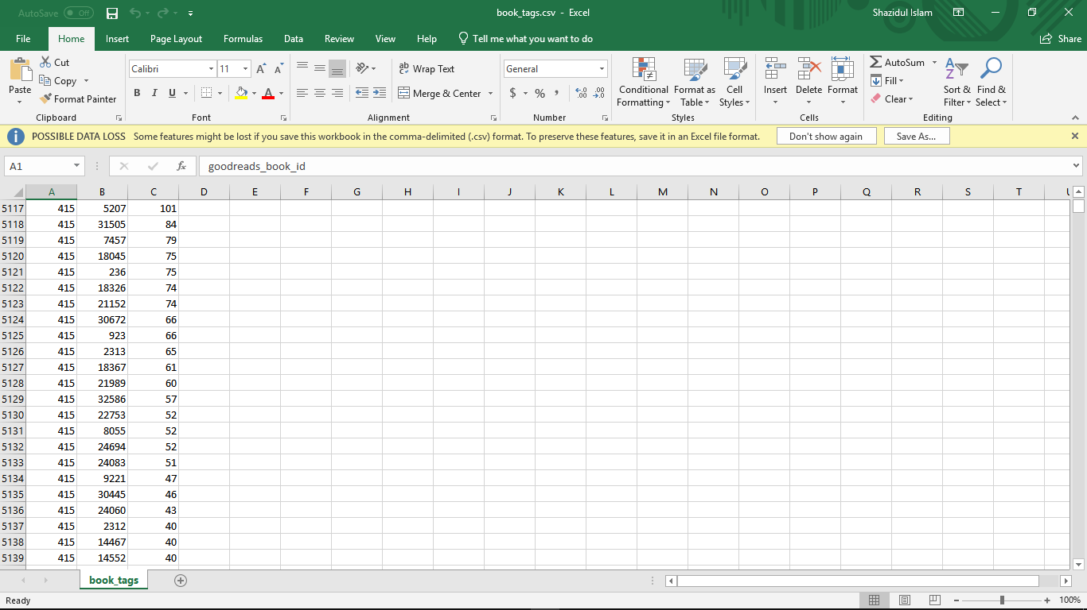

All the data that we have in the CSV file is from goodreads them self. Our teammate Alan is the one that actually maintained this database and brought it to the table.